TD 01 – PYTHON / GIT / LINUX

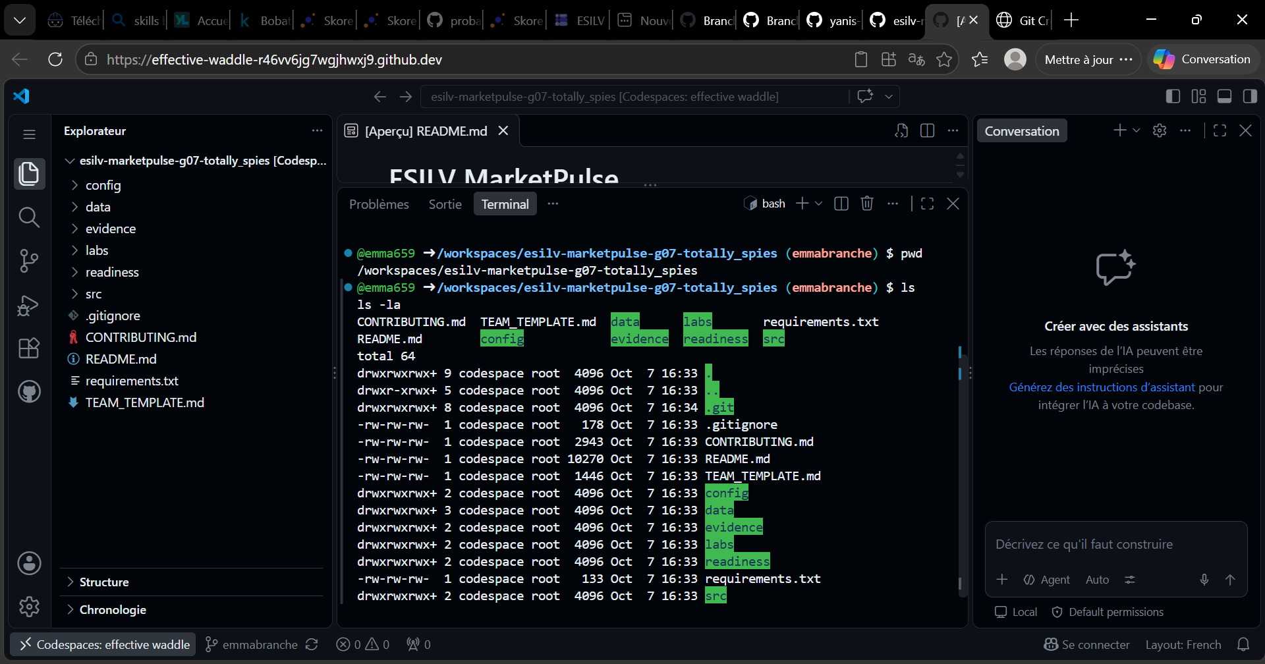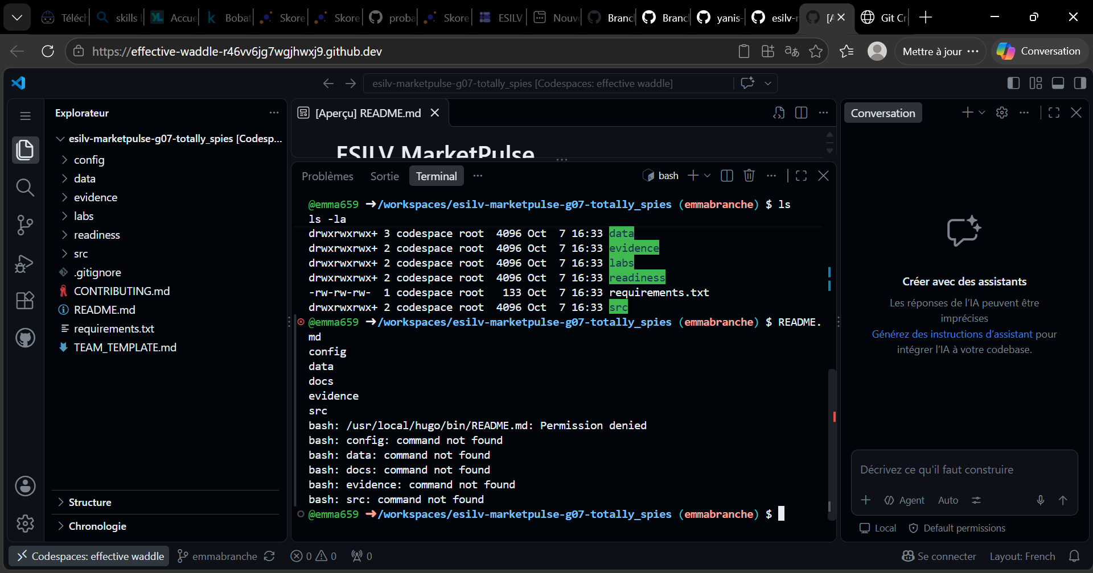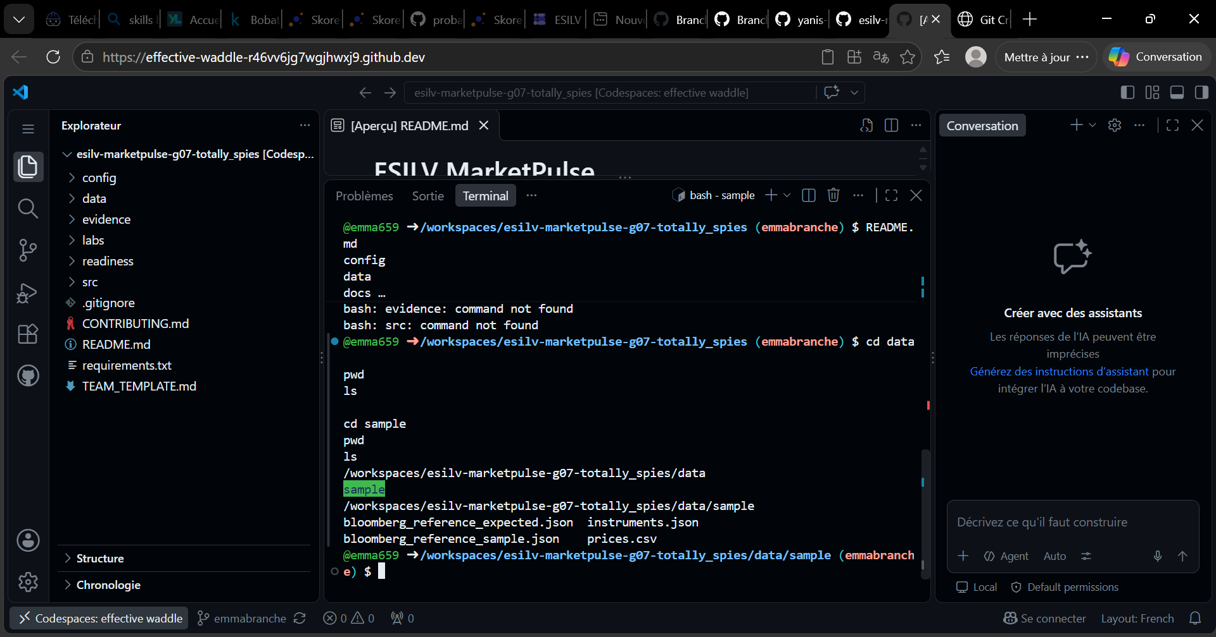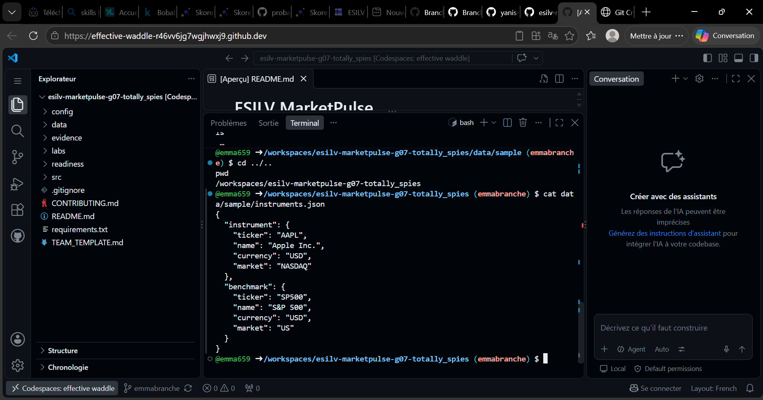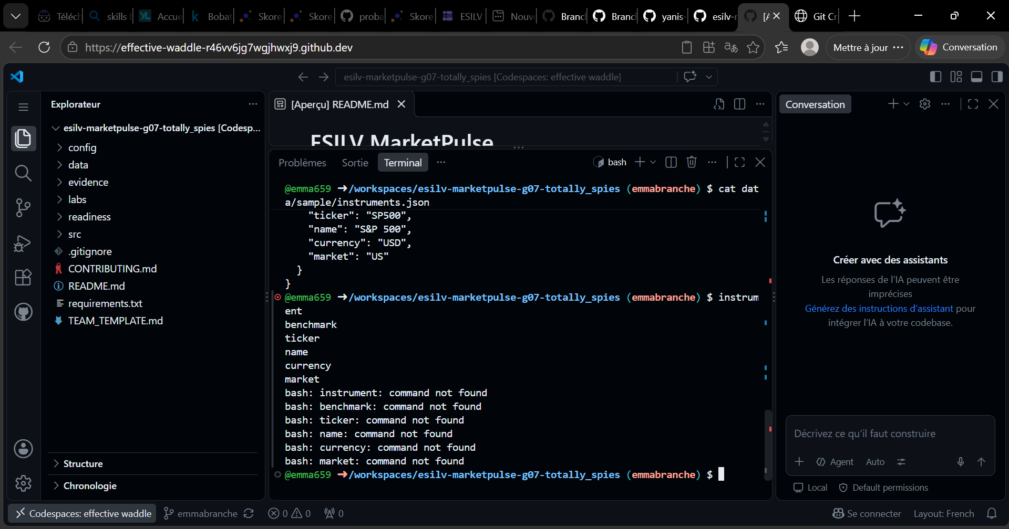

- What is the instrument?
"instrument": {
"ticker": "AAPL",
"name": "Apple Inc.",
"currency": "USD",
"market": "NASDAQ"
},

- What is the benchmark?
"benchmark": {
"ticker": "SP500",
"name": "S&P 500",
"currency": "USD",
"market": "US"
}

- Where are their names and tickers stored?
data/sample/instruments.json

